[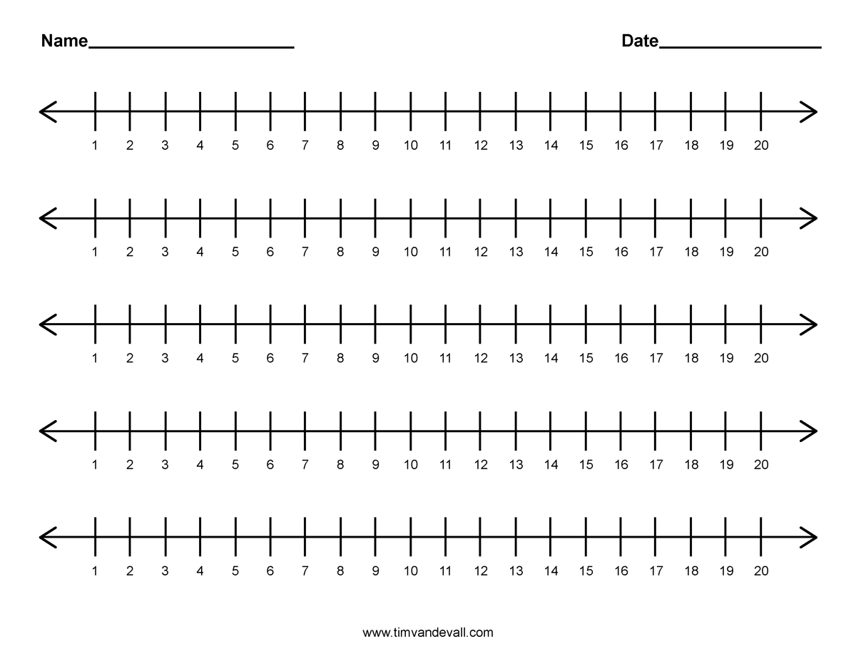](http://www.google.co.uk/url?sa=i&rct=j&q=&esrc=s&source=images&cd=&cad=rja&uact=8&ved=0ahUKEwiMneeNyZ3MAhWCWRoKHQ1bDEYQjRwIBw&url=http://www.timvandevall.com/math/number-line-1-20/&psig=AFQjCNFPtzbQz4GBoJnNAr8eCRSt8i5qvg&ust=1461253891201749)