[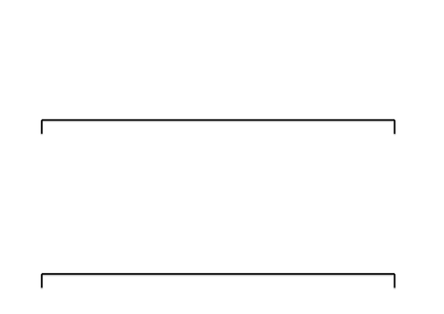](https://www.google.co.uk/url?sa=i&rct=j&q=&esrc=s&source=images&cd=&cad=rja&uact=8&ved=0ahUKEwiR9PXh25DMAhVIuBoKHag-Bh8QjRwIBw&url=https://www.tes.com/teaching-resource/blank-number-lines-6293963&psig=AFQjCNG0vAWIbKPByHsEbhYV6R7pa6fUFA&ust=1460812178127095)