|  |  |  |  |
| --- | --- | --- | --- |
| cover | best | fair | quiet |
| love | flush | free | right |
| smile | bitter | full | round |
| taste | clear | light | short |
| fly | close | low | square |
| tap | double | pat | still |
| clip | down | plain | well |
| back | even | pop | wrong |

# Supporting grammar teaching and learning at home: some useful resource ideas

**Game idea:**

How many different ways can you use the same word?

(This doesn’t mean hundreds of different sentences using the same word. This means changing the **function** of the word to be either a noun, adjective, verb, adverb etc.)  
  
Whoever finds the most functions gets the point

Example: ‘well’

Adjective: The rabbit looked healthy and well.

Noun: Snow White sang by the wishing well.

Verb: Tears welled up in my Mum’s eyes as she watched Titanic.

If you exhaust this list, you could generate your own words by picking them from magazines, newspapers, song lyrics, bedtime stories or road signs- why not have an ongoing competition!**Magnetic fridge letters:**

[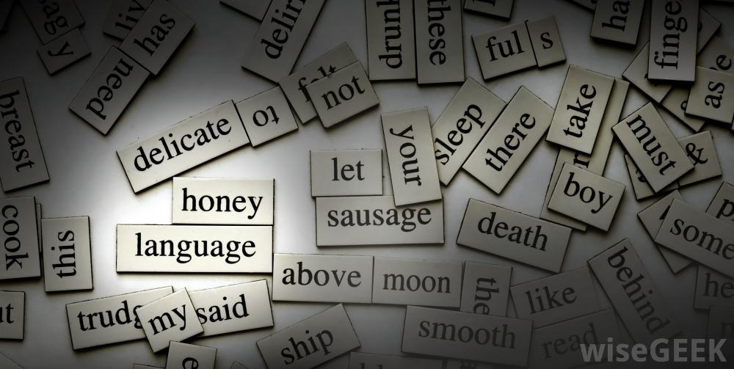](http://www.google.co.uk/url?sa=i&rct=j&q=&esrc=s&source=images&cd=&cad=rja&uact=8&ved=0ahUKEwiJscDq_rTRAhULtBQKHf_LBKYQjRwIBw&url=http://www.wisegeek.com/what-is-refrigerator-haiku.htm&bvm=bv.142059868,d.ZGg&psig=AFQjCNGIWphzTMf6Wa6nSx7maUaH0LEdNA&ust=1484048770709153)

These are a brilliant way of introducing new vocabulary because children can practise putting them into sentences and therefore begin to explore how that new word can be used.

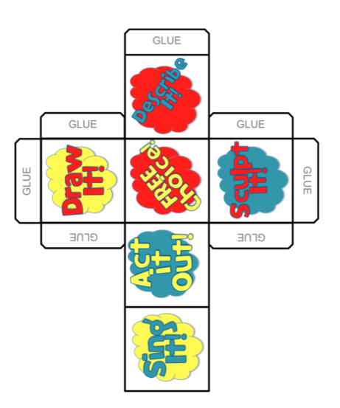

**Vocabulary learning…**  
It is important that as well as gaining exposure to lots of new words, children also have time to practise them. This will support them understanding that word enough that it can become part of their own vocabulary.

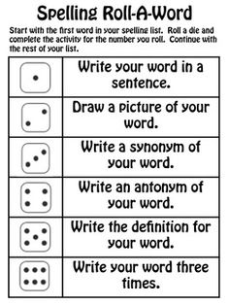There are lots of different ways this can be done:

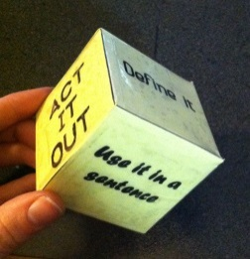- Dice games: either use a regular dice where each number dictates an action OR   
make your own dice. The actions you choose to practise the word can be as creative as you like- perhaps singing, acting or even sculpting it out of playdough!

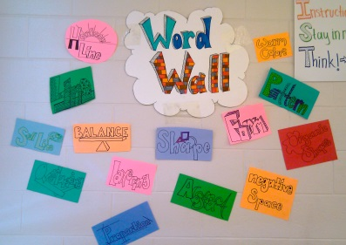- Building a word wall to log the new words your child has come across that week

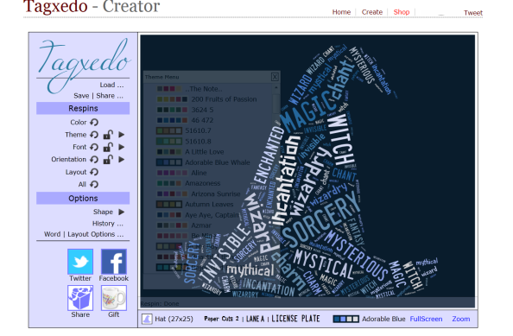- Wordles <http://www.tagxedo.com/app.html> either by logging a mixture of new vocabulary **or** choosing a theme or topic to generate vocabulary around

- Cross words/word searches where a clue is given in the form of a definition rather than a simple list of words to find <http://puzzlemaker.discoveryeducation.com/WordSearchSetupForm.asp>

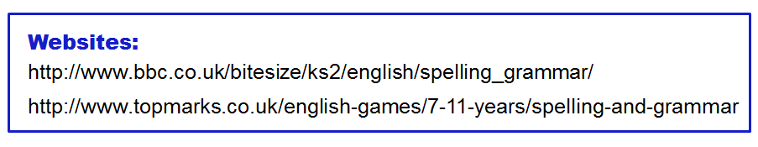

**Further ideas for supporting the teaching and learning of grammar at home**

**Playdough punctuation-** say sentence, child has to make appropriate punctuation for the sentence.

**Antonym tennis**- Player 1: Think of a word e.g. big

Player 2: think of the opposite e.g. small.

Continue until one player hesitates and can’t think of another word within 5 seconds. If this happens the other player wins a point.

**Consequences**– take it in turns to make a silly sentence using a noun, adjective or verb.

**Synonyms for said** (timed game - how many alternatives can you think of in 1 minute?)

**Noun game-** Say a noun. Child thinks of an appropriate adjective/verb to go with it. E.g. Kangaroo – jumping.