Supporting your child with spelling at home

**Word Search**

Create your own word searches using your spelling words. Or use this link to get your computer to do it for you. <http://puzzlemaker.discoveryeducation.com/WordSearchSetupForm.asp>

**Air spelling**

Choose a spelling word. With your index finger write the word in the air slowly, say each letter. Your parent needs to remind you that you need to be able to 'see' the letters you have written in the air. When you have finished writing the word underline it and say the word again. Now get you parents to ask you questions the about the word. For example they could ask 'What is the first letter?' 'What is the last letter?' 'How many letters are there?'

**Media Search**

**[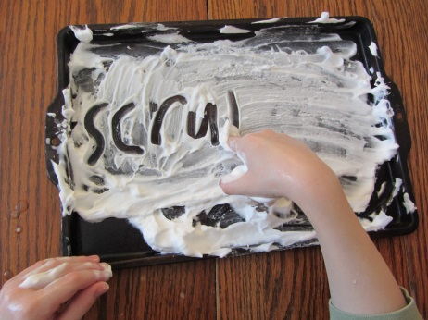](http://www.google.co.uk/url?sa=i&rct=j&q=&esrc=s&source=images&cd=&cad=rja&uact=8&ved=0ahUKEwjEvaaa8crNAhWIIsAKHbyGCY0QjRwIBw&url=http://www.theunlikelyhomeschool.com/2012/02/shaving-cream-spelling.html&psig=AFQjCNGS3SeVzSXdHtwyAW1SgMgPwgBu7A&ust=1467208856141007)**Using a newspaper or magazine you have 15 minutes to look for your spelling words. Circle them in different coloured crayon. Which of your spellings words was used the most times?

**Shaving Cream Practice**

Practise writing your spellings in shaving foam

**Salt Box Spelling**

Ask your parents pour salt into a shallow box or tray (about 3cm deep) and then practice writing you spellings in it with your finger.

**Scrabble Spelling**

[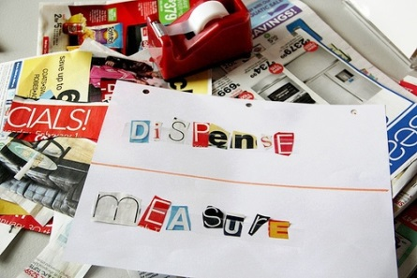](http://www.google.co.uk/url?sa=i&rct=j&q=&esrc=s&source=images&cd=&cad=rja&uact=8&ved=0ahUKEwjo57Cv8crNAhWJIsAKHRrtBxwQjRwIBw&url=http://www.aboutone.com/ways-use-magazine-for-homeschool-lessons/&bvm=bv.125596728,d.ZGg&psig=AFQjCNHzhNnsnGMQxMxH8rRxO9UbBAmV5g&ust=1467208932107999)This can be done with scrabble letters, magnetic letters or simply letters written on cards.   
Put all the letters you need spelling into a bag or muddle them up. Time yourself- how quickly can you unscramble the letters to make your word?

**Ransom Note**

Cut the letters needed to for your words from a newspaper or magazine and glue them down to spell the words.

**Spell it with beans**

Use Lima beans (or any dried beans or lentils) to spell out your words. If you glue them onto separate pieces of card then you made a great set of flash cards to practice with for the rest of the week.

**Pipe cleaners or tooth picks**

Choose a word to spell out using pipe cleaners or toothpicks.

**Tasty words**

Just like above but this time try and find tasty things to spell your words with, like raisins. Then when you spell them right, you get to eat them!

**Design a word**

Pick one word and write it in bubble or graffiti letters. Colour in each letter in a different pattern.

**Water wash**

Use a paintbrush and water to write your words outside on concrete or pavements. (Could also be done with chalk)

**ABC Order**

Write your words out in alphabetical order. Then write them in reverse alphabetical order.

**Story Time**

[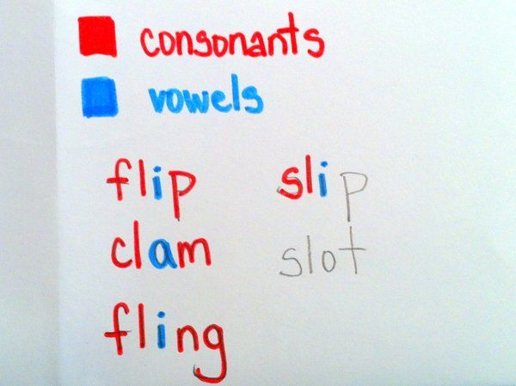](https://www.google.co.uk/url?sa=i&rct=j&q=&esrc=s&source=images&cd=&cad=rja&uact=8&ved=0ahUKEwjjlu-_-crNAhXlLMAKHZYhAEwQjRwIBw&url=https://www.pinterest.com/pin/538320961689341912/&bvm=bv.125596728,d.ZGg&psig=AFQjCNEEND5LXf3vAzWijNaiNJ4VqTeMdw&ust=1467211117284213)Write a short story using all your words; the sillier the better!

**Colourful Words**

Use two different coloured pens to write your words, one to write the consonants and one to write the vowels. Do this a couple of times then write the whole word in one colour.

**Memory Game**

Make pairs of word cards. Turn them all over and mix them up. Flip over two cards, if they match you get to keep them, if not you have to turn them over again. Try and match all the pairs.

**Finger Tracing**

Use your finger to spell out each of your words on your parent or guardian’s back. Then it's their turn to write the words on your back for you to feel and spell.

[http://opals.wikispaces.com/file/view/sp_steps.JPG/33658685/sp_steps.JPG](https://www.google.co.uk/url?sa=i&rct=j&q=&esrc=s&source=images&cd=&cad=rja&uact=8&ved=0ahUKEwjv8fHw-MrNAhWLCMAKHYGEDJ4QjRwIBw&url=https://g6-pais-ela.wikispaces.com/Spelling%2Blist&psig=AFQjCNFJMAyqJDSM1l1nlAk3r4krYKesdw&ust=1467210955007085)

**Spelling Steps**

Write your words as if they were steps, adding one letter each time. (It's much easier doing this on squared paper)

**X-Words**

Find two of your spelling words with the same letter in and write them so they criss cross.

**Ambidextrous**

Swap your pen into the hand that you don't normally write with. Now try writing out your spellings with that hand.

**Secret Agent**

Write out the alphabet, and then give each letter a different number from 1 to 26. (a = 1, b = 2, c = 3 ect.) Now you can spell out your words in secret code.

**Missing Letters**

Ask your mum or dad to write out one of your words loads of times on piece of paper, but each time they have to miss out a letter or two. Then you have to fill in the missing letters. After you have checked them all try it again with another word.

[](http://www.google.co.uk/url?sa=i&rct=j&q=&esrc=s&source=images&cd=&cad=rja&uact=8&ved=0ahUKEwjsvYmk-crNAhWeHsAKHbq0AjkQjRwIBw&url=http://pics-about-space.com/phrase-to-remember-the-planets?p%3D2&bvm=bv.125596728,d.ZGg&psig=AFQjCNGKBFnwtq8NSIT--W8KRLl-hZpnVA&ust=1467211043002017)

**Listen Carefully:**

Ask your parents to spell out one of your words then you have to say what the word is they've spelt out.

**Acrostic**

[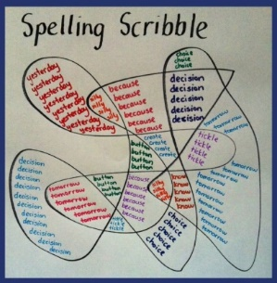](https://www.google.co.uk/url?sa=i&rct=j&q=&esrc=s&source=images&cd=&cad=rja&uact=8&ved=0ahUKEwjMp4Tm-crNAhVCLsAKHe6JDeMQjRwIBw&url=https://www.pinterest.com/pin/400961173052984728/&bvm=bv.125596728,d.ZGg&psig=AFQjCNEB_qLv954H3Ya4laytl3BRHPgPBw&ust=1467211192697793)Use words that start with each letter in your spelling word. You’re more likely to remember it if it makes sense!

**Spelling scribble:**

Make a scribble and then fill the spaces with your spellings. Use a different colour for each section.

**BAM!**

Play this game with a partner. Write the spelling words on separate word cards. Add in several extra cards that say ‘BAM!’ Place all the cards face down in a pile. Take it in turns to select a card from the pile and read it to your partner. Your partner has to spell the word on the card correctly to win the card. If you pick up a BAM card, you lose all your cards to your opponent. The winner is the player with the most cards at the end of the game. (This game could also be played with words written on lolly sticks that can be selected from a pot.)

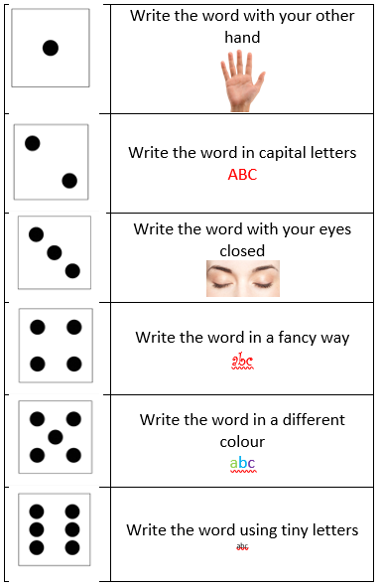

**Roll and write**Using a dice, create a different forfeit for every number. For example ‘1’ could be ‘write your word in rainbow letters’ ‘2’ could be ‘spell your word out loud in every room of the house’. This could be played like bingo whereby the players have to complete all the forfeits from 1-6 at least once to win the game. (This could also be played using M&Ms or skittles where the forfeits are attributed to the different colours rather than a number).

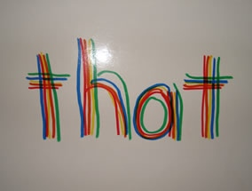

**Rainbow words**

Use different coloured pens or pencils to write over a word multiple times.

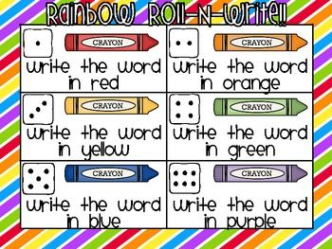

**Rainbow roll-n-write**

Write the words in the colour you role.

**Orbwars**This game will be played with tubs of ‘orbeez’ (the gel water beads that feel AMAZING!) Spellings will be hidden in the tubs of orbs, children have to race to find, look and spell as many words from the tub as they can in 1 minute.

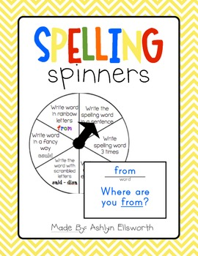**Noughts and Crosses**Play this game using 2 words instead of the traditional O X

**Spelling Spinners**   
Spin a spinner and complete the spelling activity you have landed on.

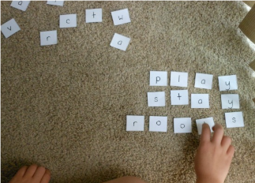**Spelling race**You need letter cards for the words you are going to call out. Call out a word for your child to race to build it out of the letter cards.

**Spelling footsteps**  
Just like Grandmother’s footsteps, children to spell the given word and step forward if its spelt correctly. If it’s not, then they don’t move! This game is best played with more than one child so it becomes a race to the finish line.