[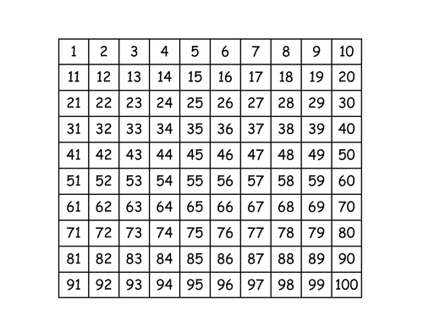](https://www.google.co.uk/url?sa=i&rct=j&q=&esrc=s&source=images&cd=&cad=rja&uact=8&ved=0ahUKEwifrsbFycjPAhXKmBoKHVc2DzkQjRwIBw&url=https%3A%2F%2Fwww.tes.com%2Fteaching-resource%2F100-square-6105585&psig=AFQjCNHBo1hqQjFfbmiwmtj3oL_nFMNwYg&ust=1475925584088367)