Useful multimedia resources



Username – oakridgeinfants

Password – Oakridgeinfants

**Mr Thorne Does Phonics: Letters and Sounds**

£2.99. iPad and Android.

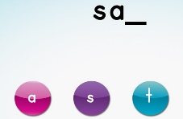

## Pocket Phonics

£1.99. iPad, iPhone

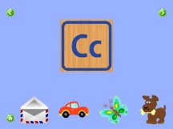

## Kids ABC Phonics

£1.99. iPhone, iPad and Android

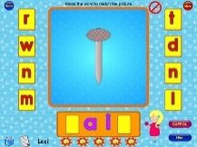

## Phonics Genius

Free. iPad and iPhone.

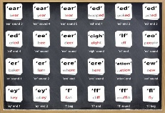

**Alphablocks – CBeebies**

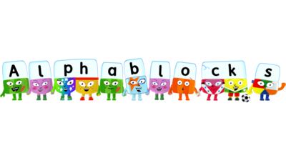

**Information and guidance for parents**

http://www.ruthmiskin.com/en/parents/